Mr. Zaw Zaw Aung
+65 8306 1684 (WhatsApp)

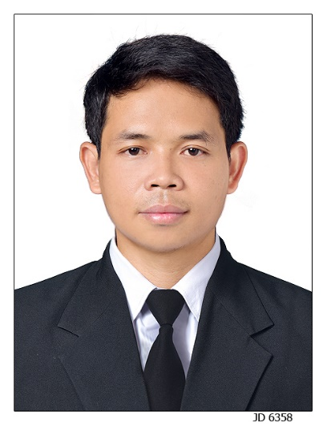

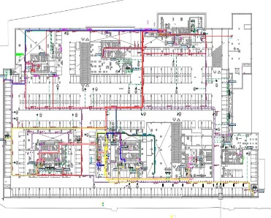
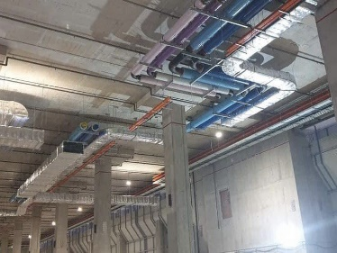
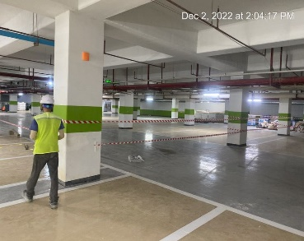
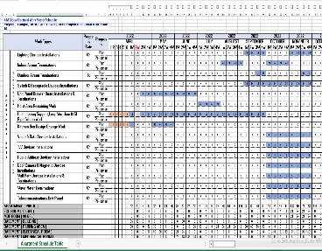
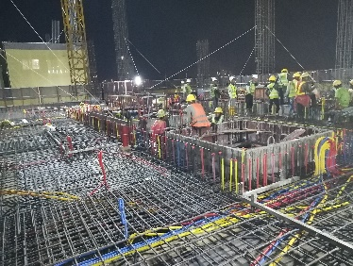
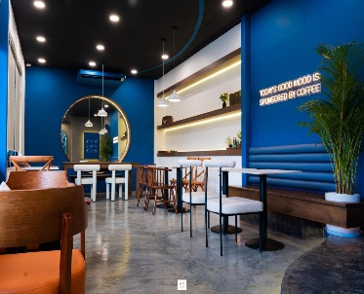
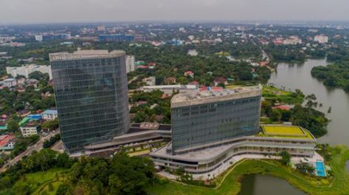
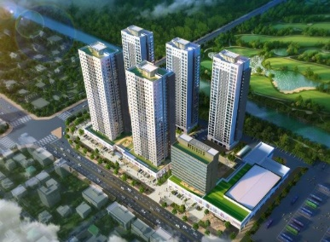
M&E Site Manager (June 2020 – Apr 2023)
KM Global Construction Company Myanmar
- Assisted to my Project Manager for inspecting, scheduling and manage to all M&E services and process.
- Prepared plans, detailed, specified cost estimate for M&E system in project.
- Created drawings in coordination with other engineering sections; Architecture, Construction, Interior Design, and others.
- Reviewed the plans and specifications according to the project.
- Directed and closely to the clients for their requesting and negotiations.
- Monitored and supervised the M&E service works and finish in time to meet the project timeline.
- Managed the teams day-to-day working procedures.
- Attended the project management, site and department teams meetings.
- Made sure that all the site progress within the desired budget.
- After finish the project, inspected everything must be qualified as we described to my clients.
- Scheduled and assigned plans for the further maintenance routings.
Electrical Engineer (Feb 2018 – May 2020)
KM Global Construction Company Myanmar

- Reviewed and aligned electrical design drawings to ensure compliance with design specifications and guidelines.
- Managed the materials and controlling of unnecessary of wastes.
- Attended the internal meetings to discuss the problems that related to projects.
- Reported every job sheet to the manager day by day.
- Provided technical support and assist Manager in project planning and coordination of all site activities.
- Daily coordinated and managed to Site engineer and Team Leader for all sector.

zawzaw.engr1728@gmail.com

Blk 501D #09-90 Wellington Circle Singapore (754501)
I have more than 7 years of working experience in Mechanical and Electrical Engineering field in construction and industry. Depend on my experiences, I have good engineering skills as working schedule and daily plan, manpower control, site management, M&E design and systems (Myanmar based), Auto CAD and Revit (MEP). I am interested in a challenging technical track carrier in engineering. And I am able to work independently and handle in any deadlines.
PROFILE SUMMARY
Bachelor of Engineering, Electronics
(2009 – 2015)
Technological University,
Pakokku, Myanmar
Personal Information
DOB : 29 May 1989
Marital Status : Single
Passport No : MH153176
Nationality : Myanmar
Availability : Immediately
Expected Salary : SGD 2500 (Nego)
Technical Skills
Project Management

Microsoft Office

Auto CAD
Revit (MEP)
M&E System & Design
Working Experience
M&E Engineer

Education Background
Interests
M&E Site Engineer (Mar 2016 – Jan 2018)
KM Global Construction Company Myanmar

- Supervised to the general workers in all process of manufacturing.
- Checked Electrical Power installations, Panel installations, Lightening and Earthing System.
- Examined Extra Low Voltage system, CCTV, Public Address, Home Automation system, MATV, Voice and Data daily site checking.
- Daily checked Fire Alarm, Basement and Bus Terminal Car Parking Control and Monitoring system.

- Prepared the detailed schedule of the M&E works and get it approved from my senior engineer for further action.
- Worked under the direct command and management of my Senior Engineer.
- Learned and studied the working process in site conditions.
- Attended site meetings and ensure daily schedule for timely completion of projects.
- Worked within project deadlines and prioritizing task from time to time as scheduled.
- Checked the electrical devices and fixtures installations finished works.
- Studied the ELV works Card Access System, Video Intercom, Master Antenna Television, Nurse call, CCTV and Telecommunication Distribution (Direct and PABX) System).
- Reported to my Senior Engineer finishing of installation in Mechanical works such as ACMV systems, Fire Fighting systems and Plumbing Sanitary systems.
- Maintained and checked the M&E works day-to-day working procedures.

Reading

🎧

⚽⚽⚽⚽⚽⚽

Music
Burmese : Native
English : Fluent
- Project Management
- M&E Services Course
- Auto CAD Intermediate Course
- BIM Modeling Revit (MEP) Course
- Electrical Low Voltage Design
- Working At Height Safety Course
- Team spirits
- Handle in any deadlines
- Responsibility
- Flexible attitude
- Attention to details
- Hardworking
- Fast learning
Other Certificates
Language
Photo Reference
Personal Skills
Traveling
✈️
Football

